Control Engineering

Handout – Online Laboratory I

Name: *Colda Andreea Ariana*

Group: *30332*

1. It is considered a process characterized by the transfer function . What is the gain of the proportional controller which can ensure a steady-state speed error smaller than 0.1.

*Kp>10*

1. For the structure from *figure 6* it is considered the fixed part .
   1. Using both MATLAB and analytical calculus, determine and compare the steady-state position, speed and acceleration errors for the system for four type of controller: a proportional controller with the gain Vr=1, 2, 5 and a PI controller with Ti=1 and Vr=2.

Vr = 1 position: *0.16*

velocity: *infinity*

acceleration: *infinity*

Vr = 2 position: *0.09*

velocity: *infinity*

acceleration: *infinity*

Vr = 5 position: *0.038*

velocity: *infinity*

acceleration: *infinity*

Ti=1 and Vr=2 position: *0*

velocity: *0.1*

acceleration: *infinity*

* 1. Determine the closed loop transfer function from disturbance “p” and highlight the effect of a step disturbance to the output using a P controller (Vr=2) and then a PI controller (Vr=2, Ti=1);

*Hpi = (2s^2 + s )/(2s^2 + 11s + 10)*

*Hp = (2s + 1)/(2s + 11)*

Vr=2 (P controller):  *not completely rejected*

Vr=2, Ti=1 (PI controller):  *completely rejected because of the integrator*

* 1. Considering that the disturbance “p” is varying in steps, plot the system output in the case of step reference signal. The disturbance steps are: 0.2, 0.3, 0.4. Rise the load characteristic using a PI controller (Vr=2, Ti=1).

w

ε

y

c

-

+

Hr

Hf

*Figure 6*

p

*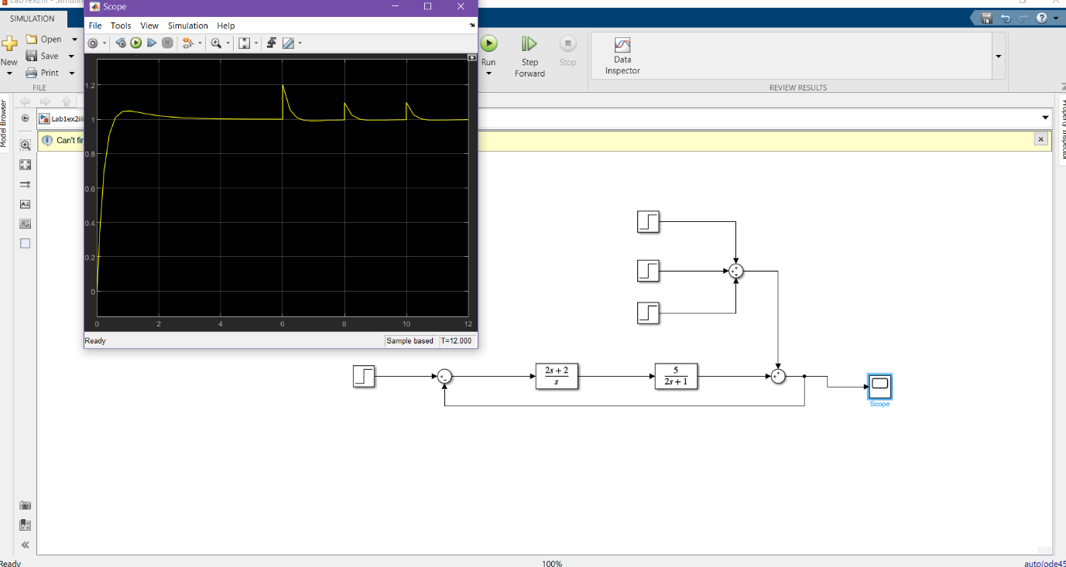*

1. It is considered the system from *figure 7* for which we have  and . Determine the closed loop transfer functions from step reference signal with respect to disturbances p1 and p2. Plot the output of the system with respect to the disturbances.

p1

w

ε

y

c

-

+

Hr

Hf1

*Figure* 7

p2

-

-

+

+

Hf2

*For p1: Ho1(s) = s/(s^3+2s^2+2s+2)*

*For p1: Ho2(s) = s^2/(s^3+2s^2+2s+2)*

*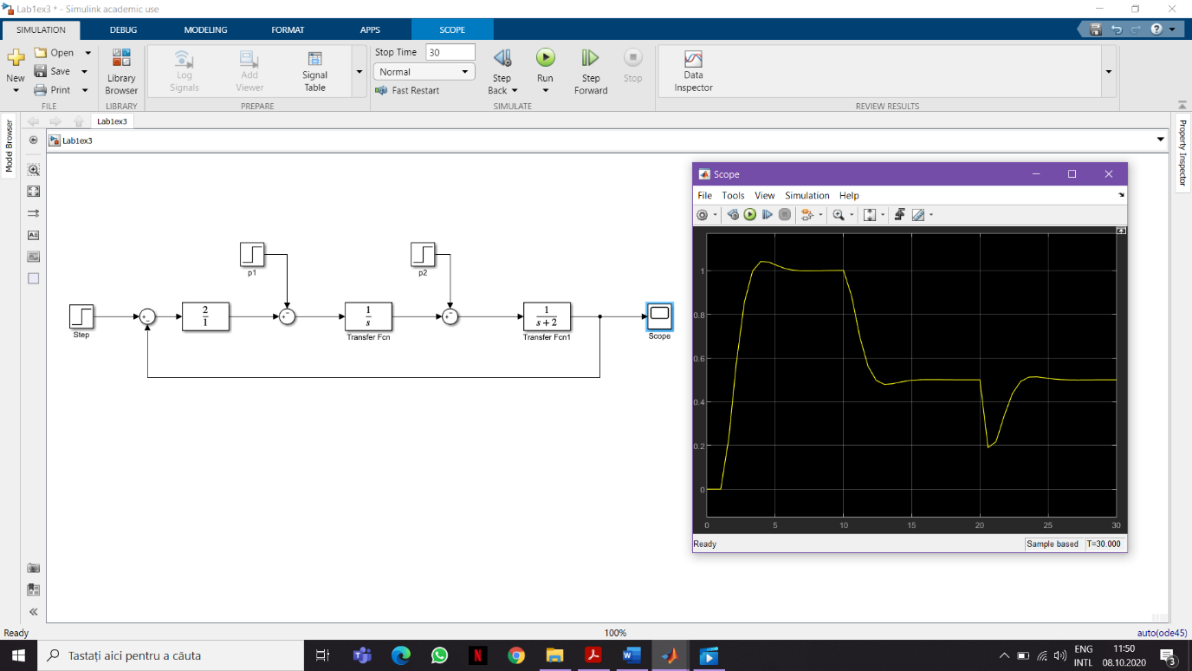*

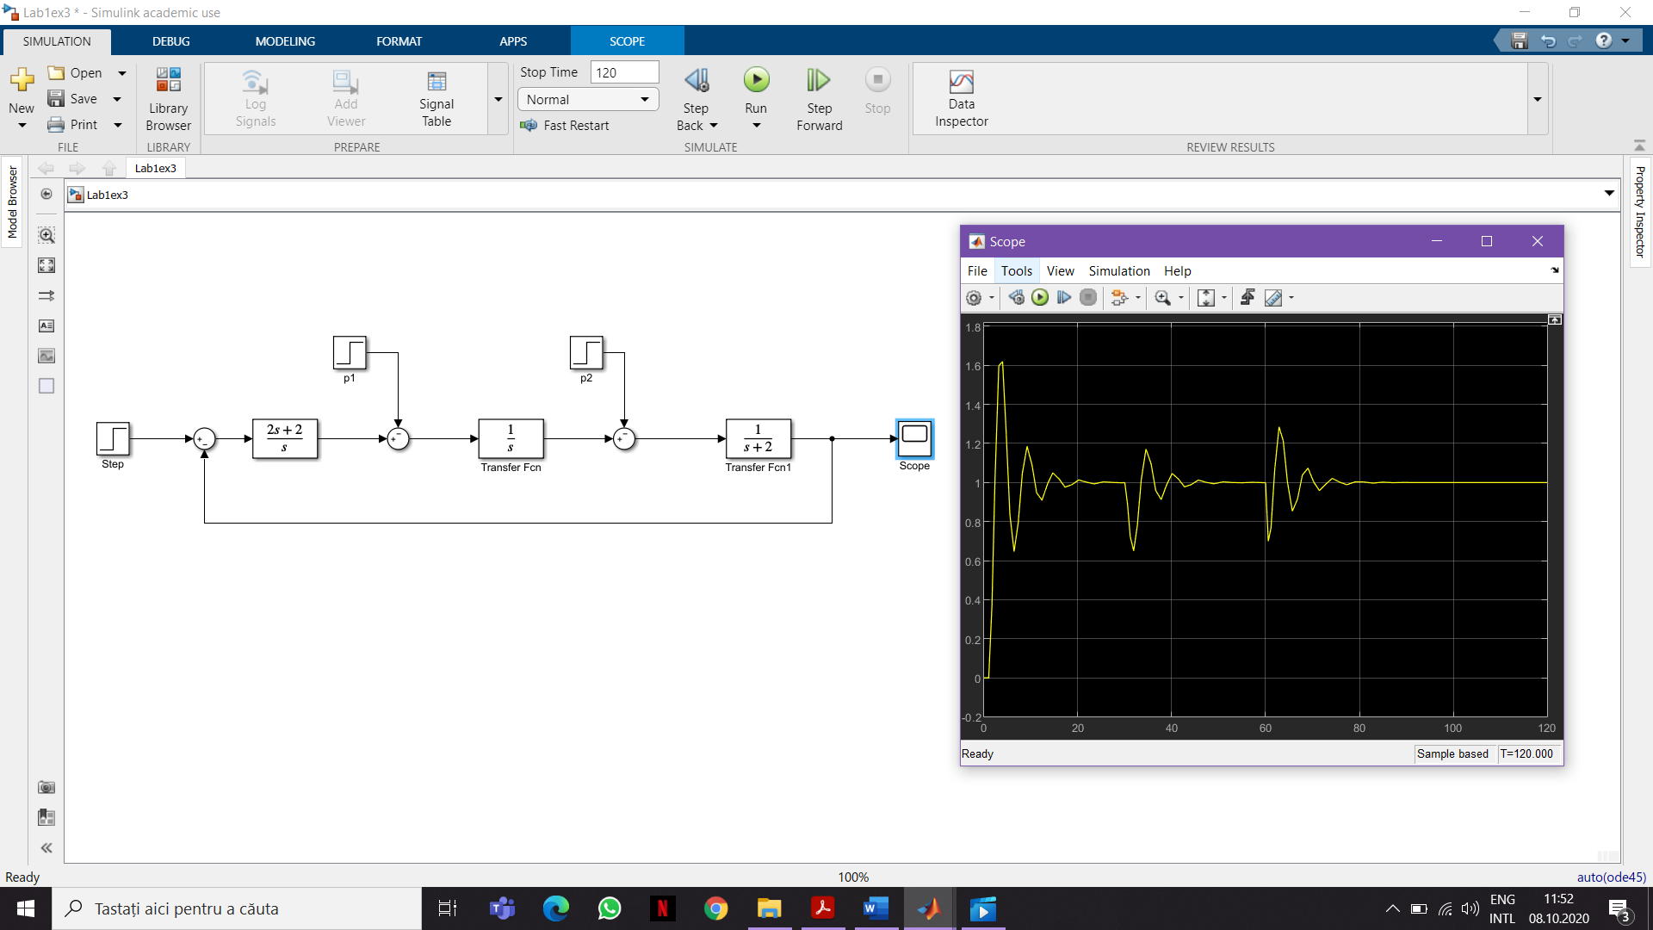

1. Consider the closed loop system from *figure 8*, where  and , the controller  with .

Study the response of the closed loop system considering the following scenarios:

* At a unit step reference

*Add plot here (screenshot from Matlab) and a few comments regarding the response*

* At a unit ramp reference

*Add plot here (screenshot from Matlab) and a few comments regarding the response*

* At the presence of the disturbance *p1* – step signal of amplitude 0.2

*Add plot here (screenshot from Matlab) and a few comments regarding the response*

* At the presence of the disturbance *p2* – step signal of amplitude 0.1

*Add plot here (screenshot from Matlab) and a few comments regarding the response*

ε

-

+

Hr

c

w

Hf1

p1

Hf2

y

p2

-

+

*Figure 8*

1. Considering the control structure from *figure 9*, compute the steady-state errors for the following references: 5r(t), 5tr(t), 5t2r(t), where r(t) is the unit step signal.

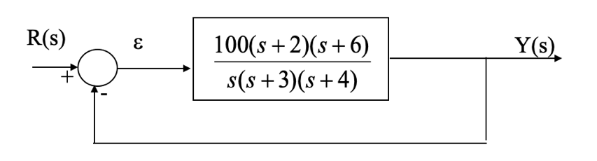

*Figure 9*

5r(t): *add steady-state value here*

5tr(t): *add steady-state value here*

5t2r(t): *add steady-state value here*

All done? Great job 🍾🎉🎊! Upload this document along with your Matlab/Simulink files in the Assignments section of the Control Engineering I group in Teams (pay attention to select the correct Assignment!).